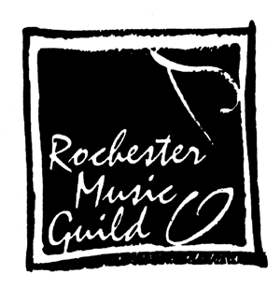 **Grant Application**

# Rochester Music Guild

P.O. Box 5802, Rochester MN 55903

RochesterMusicGuild.org

**Please note:** *Applications are due by* ***June 1, 2025*** *for projects to be completed prior to June 2026*.

The purpose of the Rochester Music Guild (RMG) is the promotion of music appreciation through education and performance. To meet these goals, RMG has authorized limited funds for grants to non-profit music organizations in the Rochester, Minnesota area. Grants up to $500 may be made as approved by the RMG Board of Directors to 501(c)(3) organizations who provide such education or performance opportunities.

**Grants may not be made for salaries or benefits of employees, or for administrative expenses necessary for the operation of an organization. Grant objectives should be consistent with the above goals.**

Forms and required materials may be mailed to: Rochester Music Guild, PO Box 5802, Rochester, MN 55903

Or emailed to: [rochestermnmusicguild@gmail.com](mailto:rochestermnmusicguild@gmail.com)

**Organization submitting this request:** **_______________________________________________________**

**Address: ________________________________________________ Email: _________________________**

**Contact: _______________________ Phone: ________________ Email: ____________________________**

Any questions about this request will be directed to the Contact person listed.

**Note: If this is a first-time request, please submit a copy of the organization’s 50l(c)(3) letter.**

**Amount requested: $_____________ Activity Goal: ____ Education ____ Performance**

**Purpose (be as specific as possible about how funds will be used – attach an extra sheet if needed):**

**__________________________________________________________________________________________**

**__________________________________________________________________________________________**

**Overall cost of activity: $_________ How is the balance of the expense being met?*___________________**

**__________________________________________________________________________________________*Please attach a copy of the DETAILED BUDGET for the project.**

**Recognition of the Rochester Music Guild's support is a requirement for receiving this grant. Please indicate how you plan to promote or publicize the Guild's participation.**

If approved, a check will be issued to the Organization listed. Please provide the name of the organization as it should be written on the check and an address to mail the check if different than above:

_____________________________________________________________________________________

Submitted by: ______________________________Position: __________________Date: ______________

Grant Application Form